**Gallery**

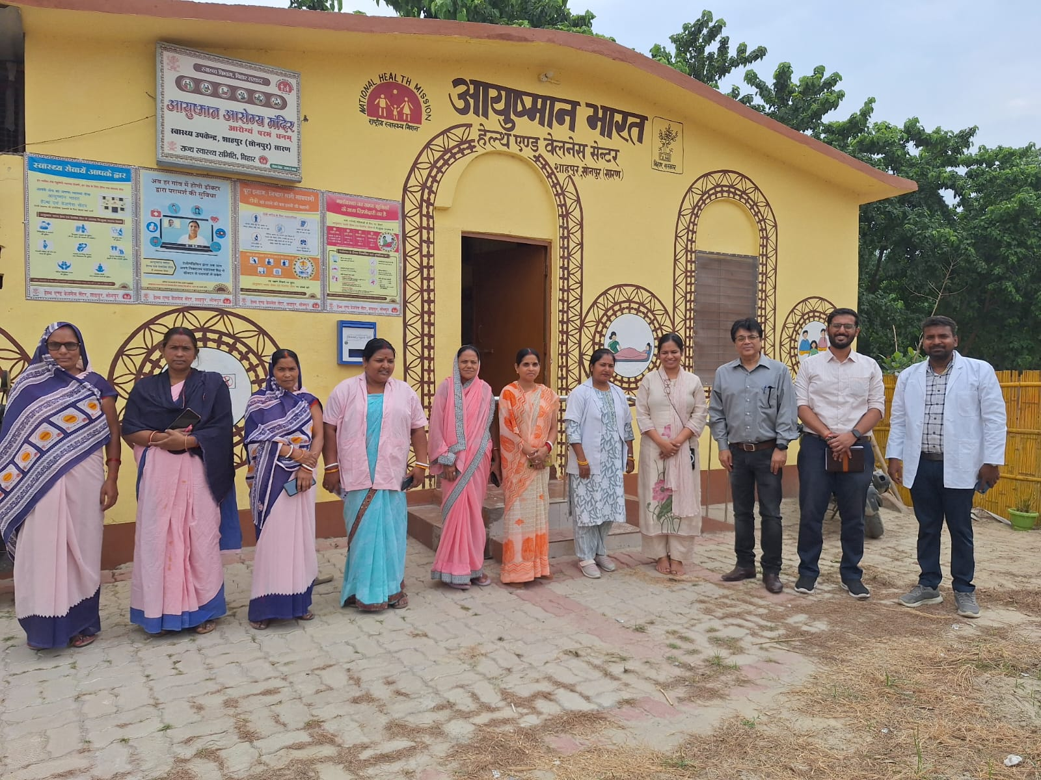

Figure: Visited UPHC Shahpur, Saran (Bihar) to observe the AAM key signal functions to advance the broader urban health mandate.

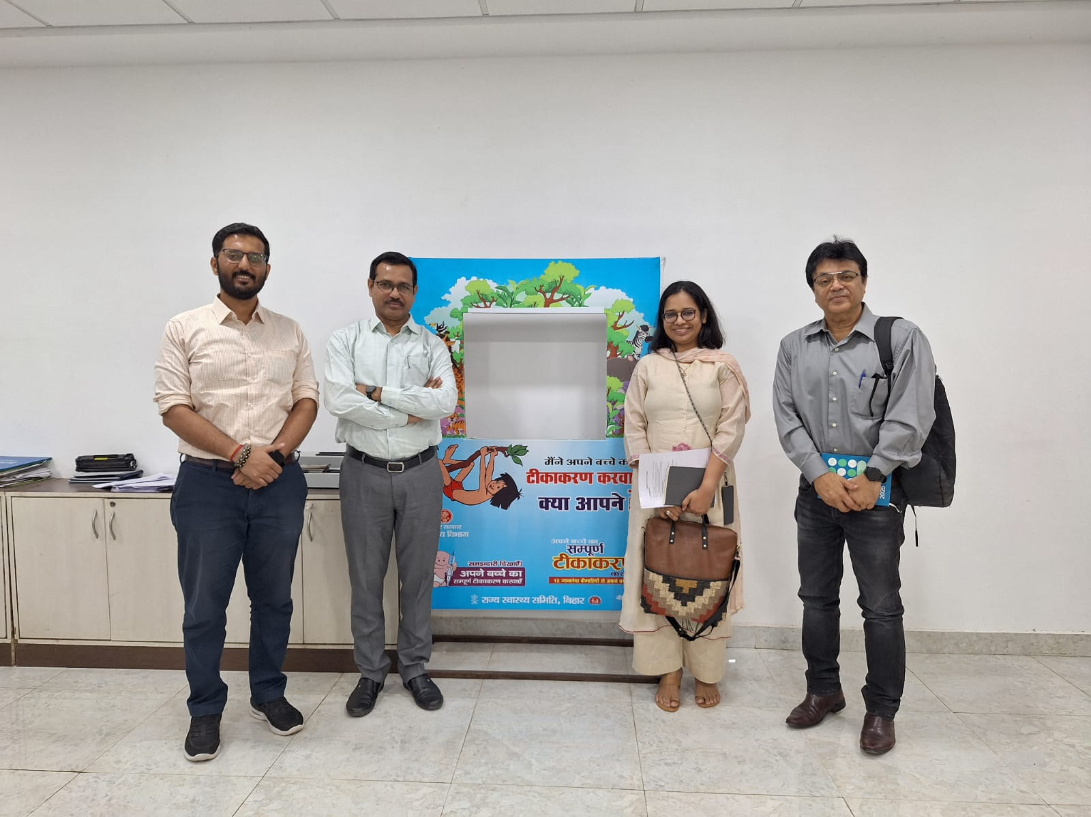

Figure: Project Director – Urban RI visited State Health Society to align with state priorities and explore project expanding horizons

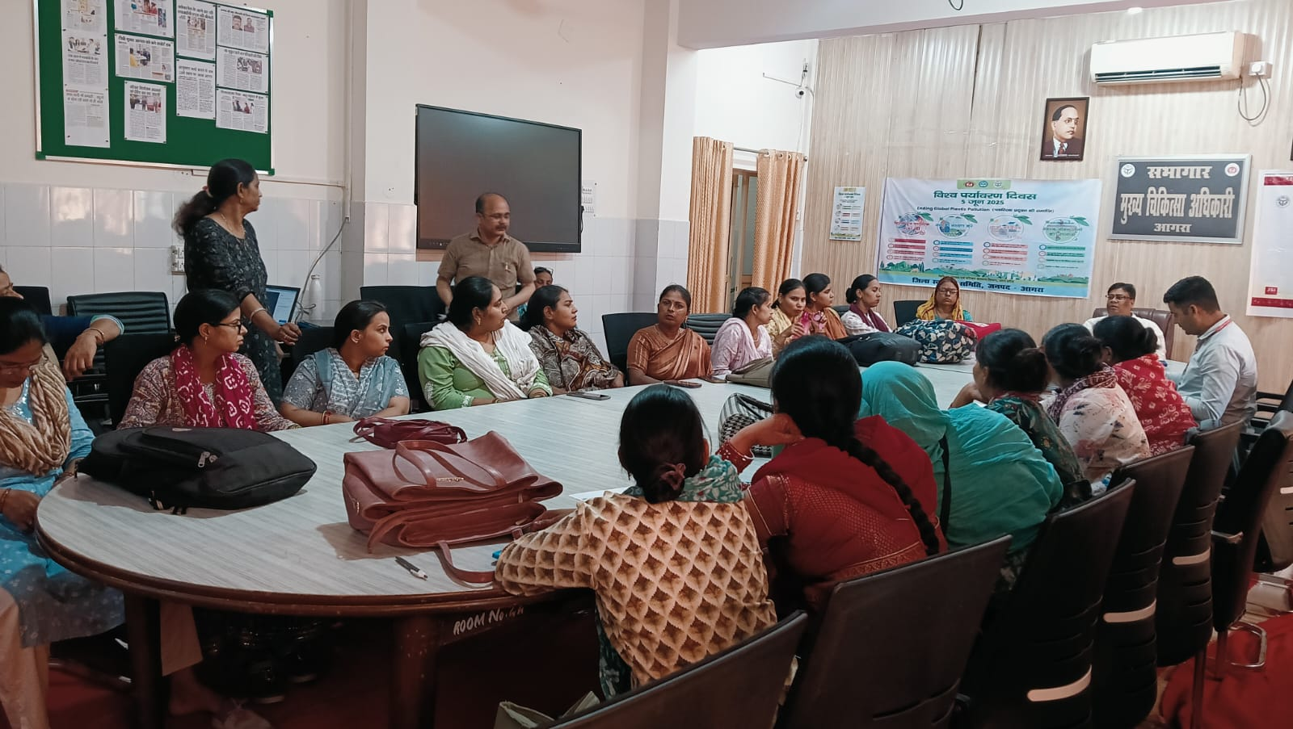

Figure: Project supported optimization of the U-WIN digital RI interface to streamline the transition from paper-based to portal-based reporting.